1. Create a sample table in postgres/mysql with following columns (15 Marks) Table Name : cdac_power_bi Column Name - varchar Id- integer Age- integer Dob - date Insert 5 dummy rows into it and then connect to superset and populate 1. Table Chart 2. Card chart showing max age

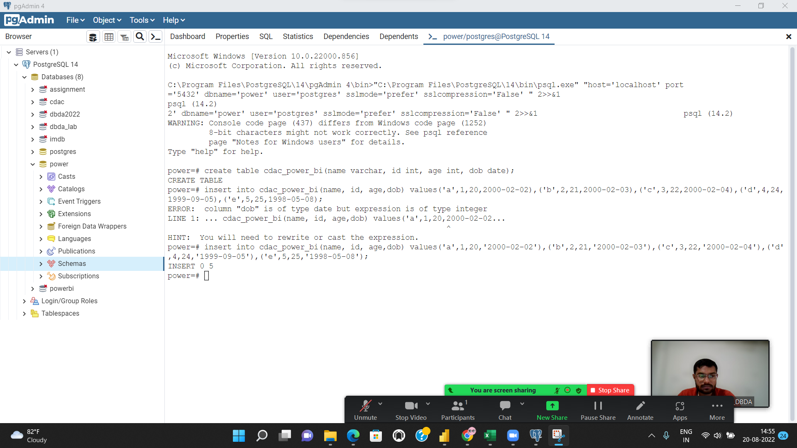

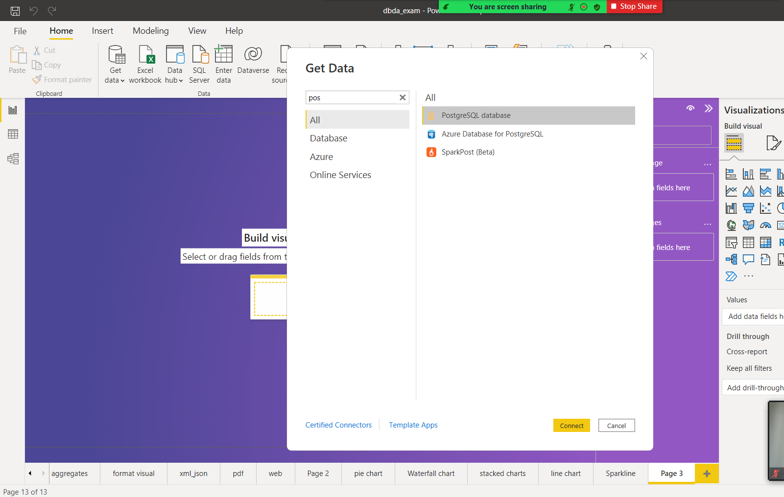

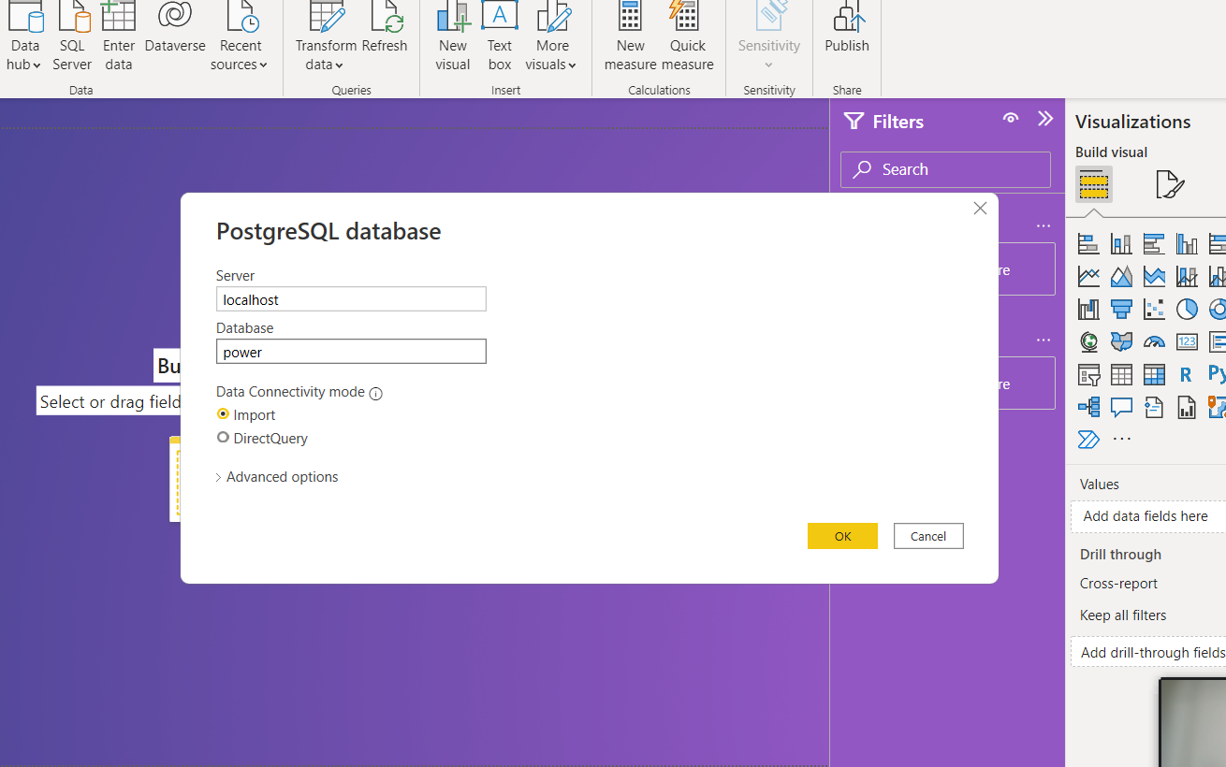

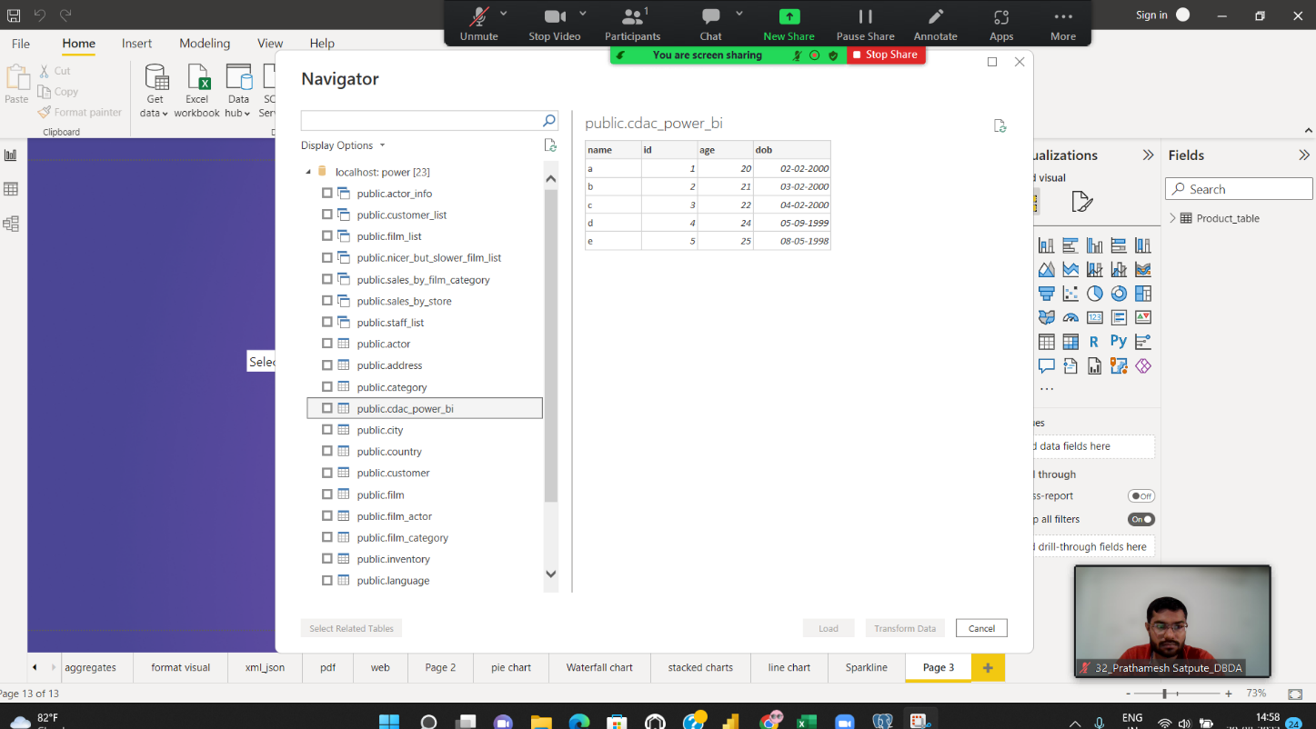

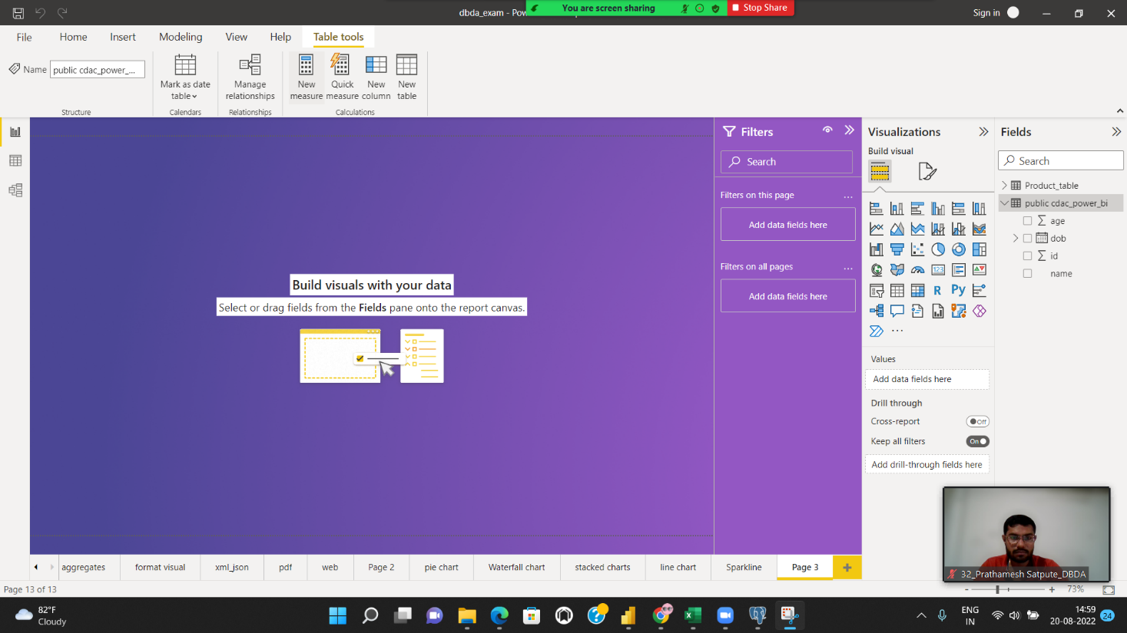

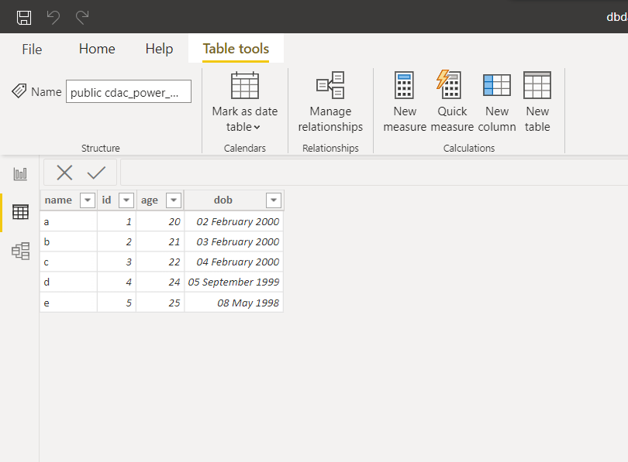

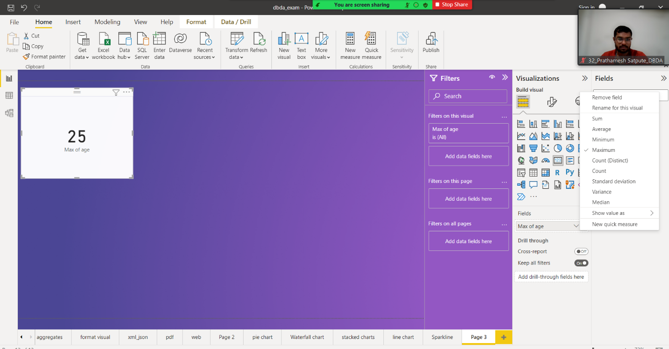

Q2.On product_table data set do the following (25 Marks) ● Create table chart with title , vendor,customer name,quantity,price,city ● Add new calculated column naming total_sales which is derived from quantity * price ● Add new measure naming max_price to get max of price column and then display every vendor max price in table chart ● Create pie chart showing the value and percentage of quantity by vendors ● Create one more column naming total_sales_2022 which is derived from quantity * price * 1.16 ● Create clustered column chart showing both total_sales and total_sales_2022 ● Create a slicer chart of price ● Calculate avg sales and show in tile ● Create gauge chart with ○ value as total_sales ○ Maximum value as max of total_sales_2022

Load data

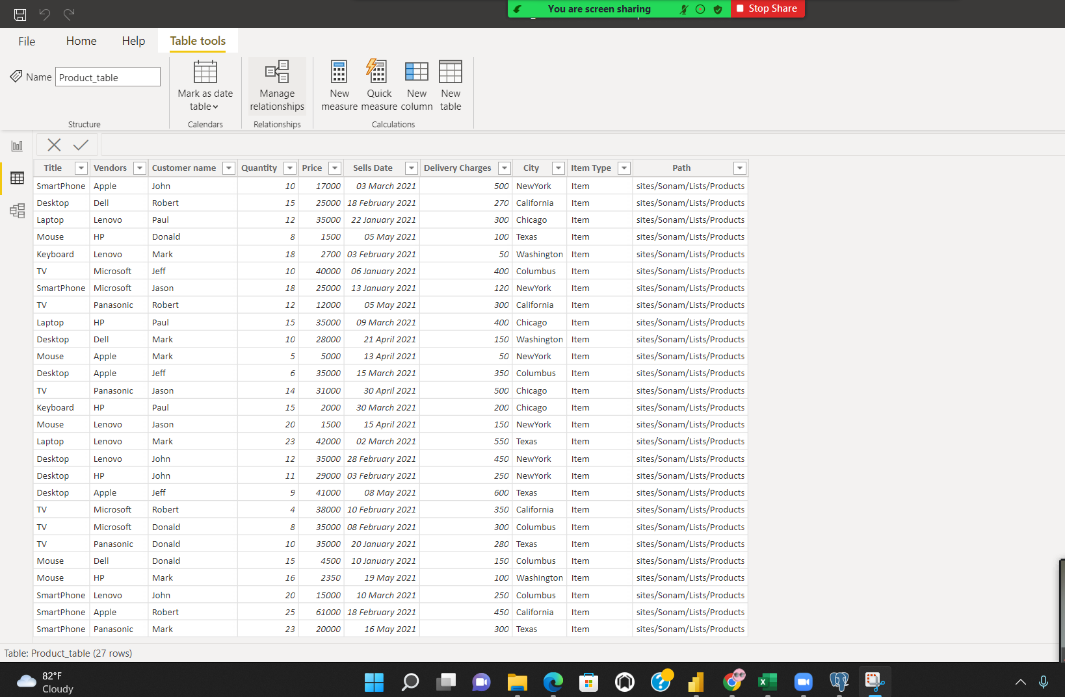

Add and calculate column total sale

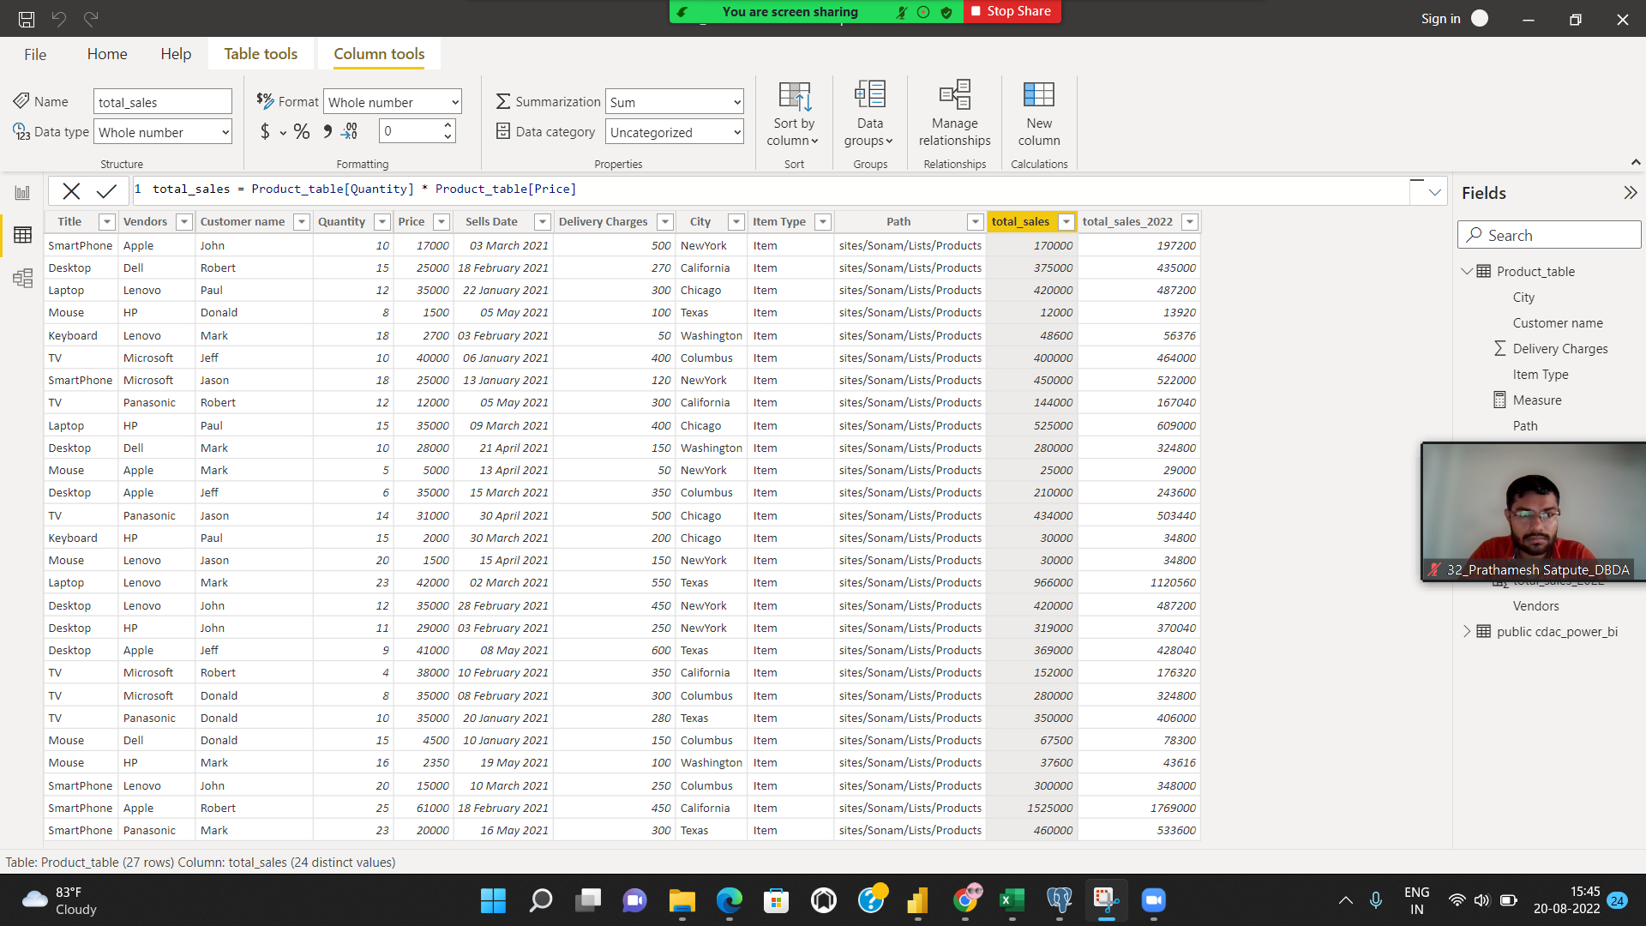

Add and calculate column total sales 2022

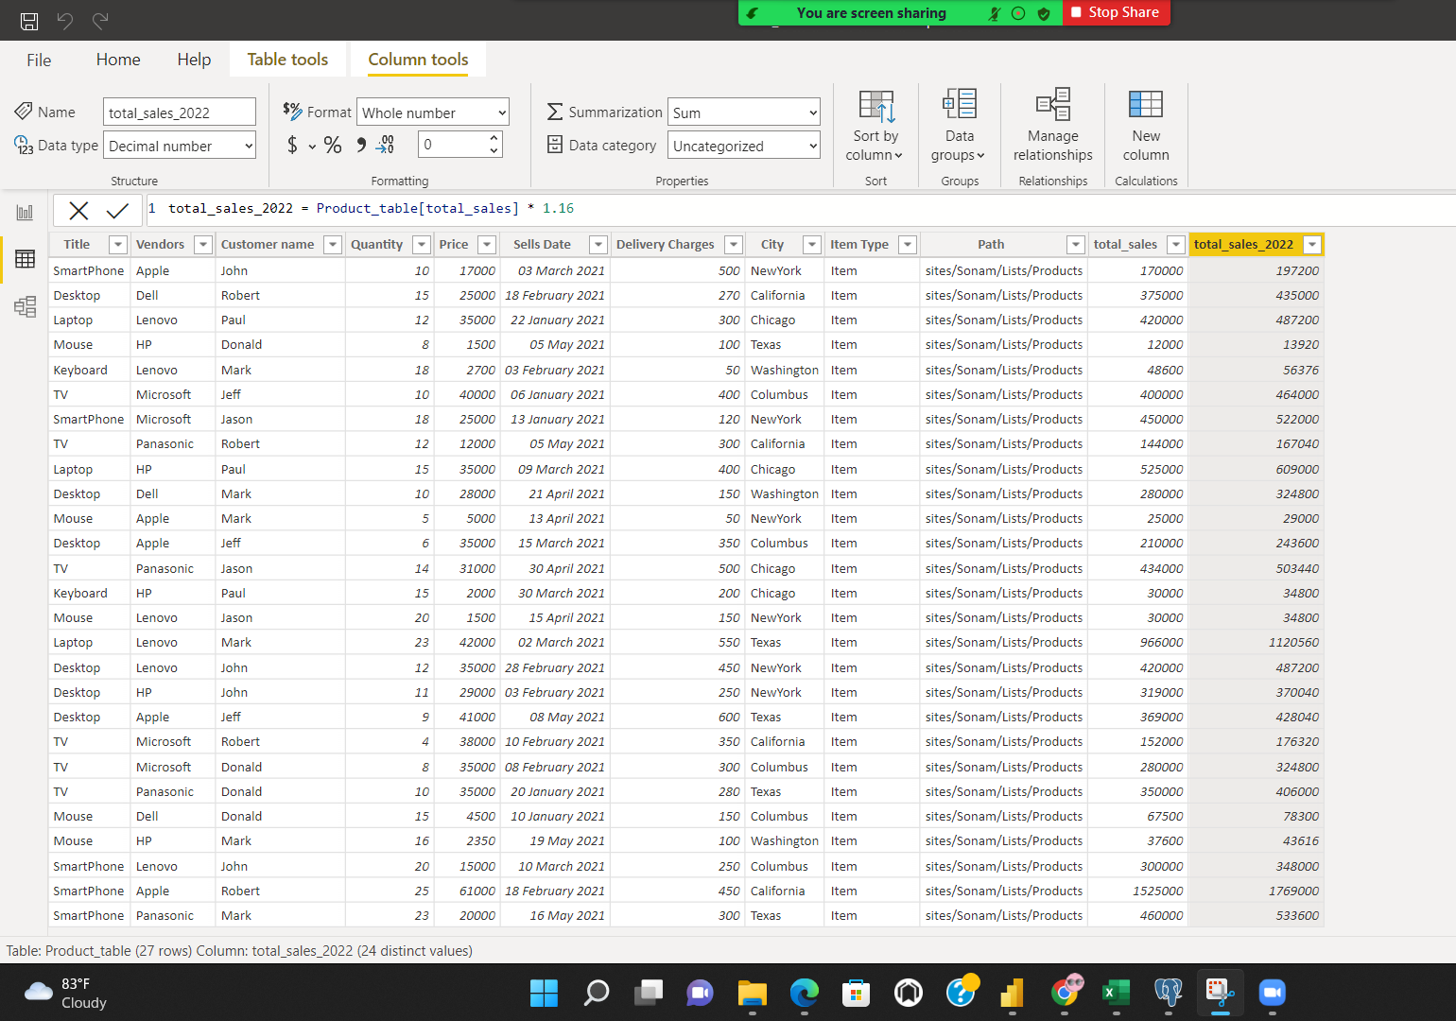

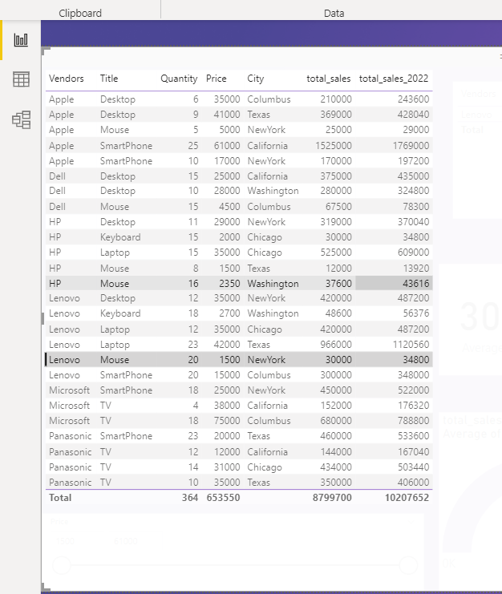

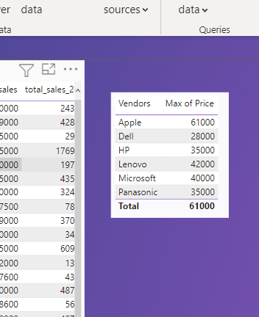

Pie chart

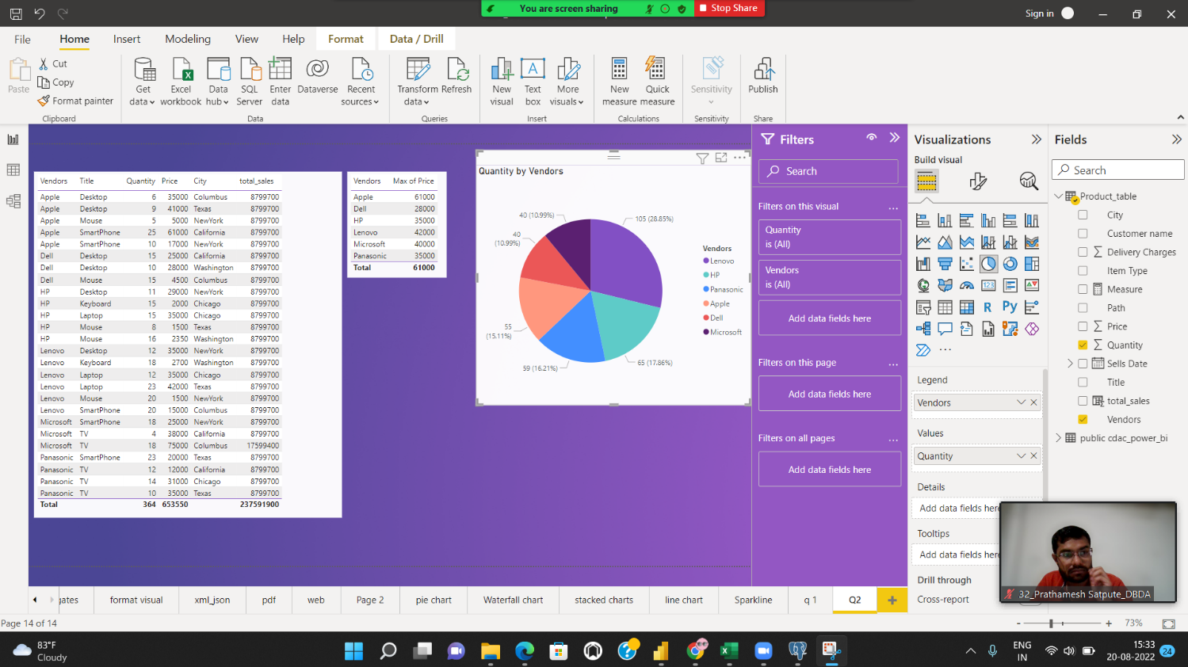

Clustered chart

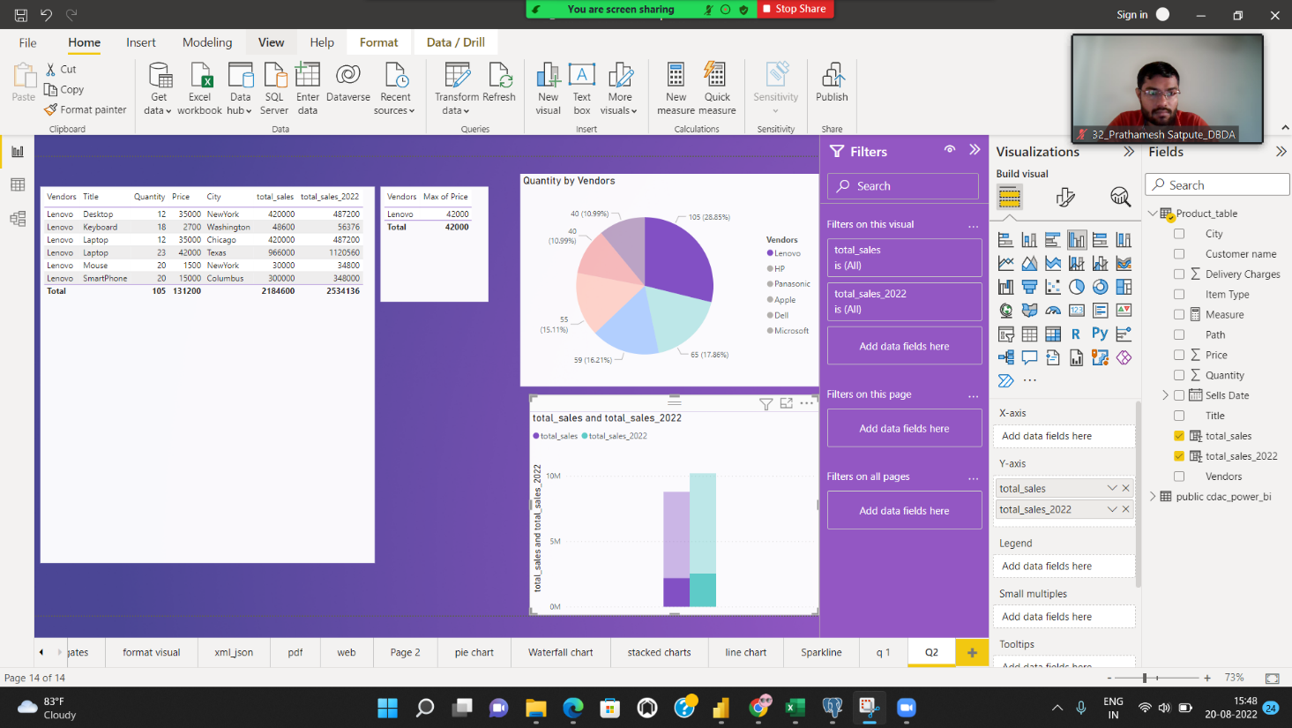

slicer

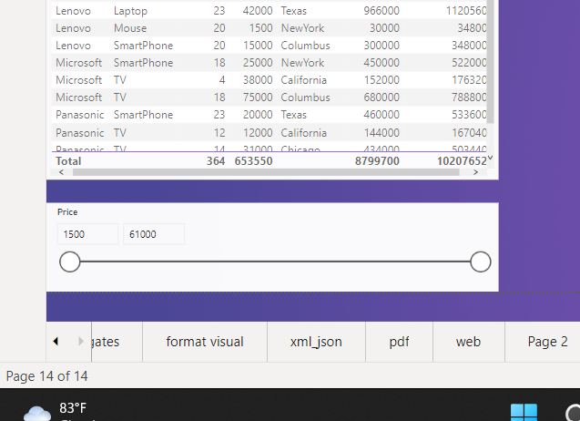

Gauage chart

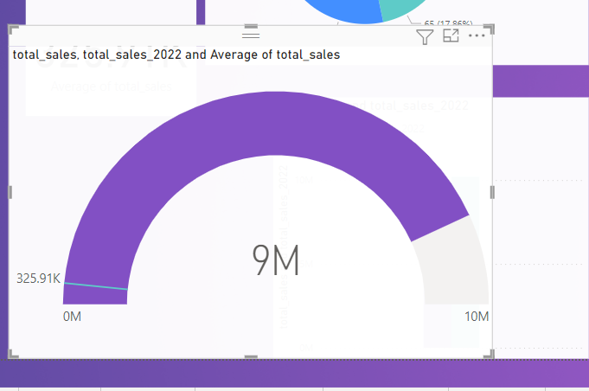

Final

